

**Lab Goal:** To get more familiar in using multiple loops and if statements to accomplish a multitude of tasks. You will need to use three methods, all of which will include one or more loops and if statements. This will better your understanding on how loops and if statements react with one another to accomplish the overall goal of the lab.

**Lab Description:** In order to complete this lab, you must use a loop to guide Eddy through the maze to reach his friends who are trapped between fences. Along the way, you must collect flowers which will be used to help free Eddy’s friends that are stuck in a trap. After you have freed Eddy’s friends, you must help all of the Jeroos escape to the flower island at the end of the maze. Good luck!

.



**Starting Screen:**

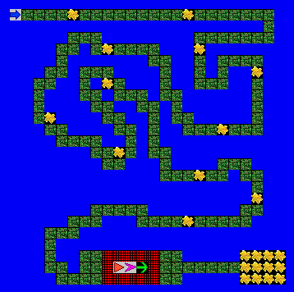

**Ending Screen:**

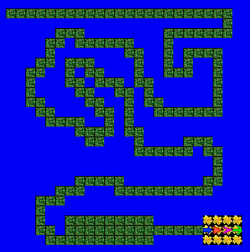

**BONUS: Collect all of the flowers on the island. +10**